**Part 1: House Construction**

Name: ____________________ Date: ______________

MAKE Tree Worksheet

**Prompt:**

*Brainstorm qualities of a house that represent who you are, your goals, and where you want to be.*

**Directions**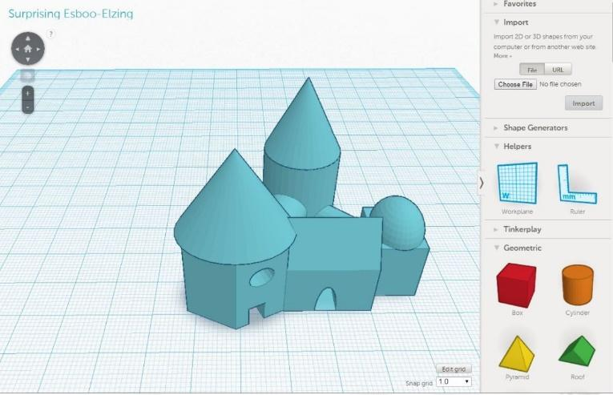

1. Answer brainstorm questions with a mentor.
2. Answer questions about sculpture concept/idea. Share with a mentor for approval to move on.
3. Look at Tinkercad Shape Inventory to plan the design of your sculpture based off of your drawing

*\*Remember improvisation is key\**

1. Design at least two sketches of your desired design. Show a mentor to see if the object is possible to create.

*Essential Questions:*

*How does this sculpture represent who you are?*

*How does this sculpture represent your goals?*

*How does the sculpture show where you want to be (personally and academically)?*

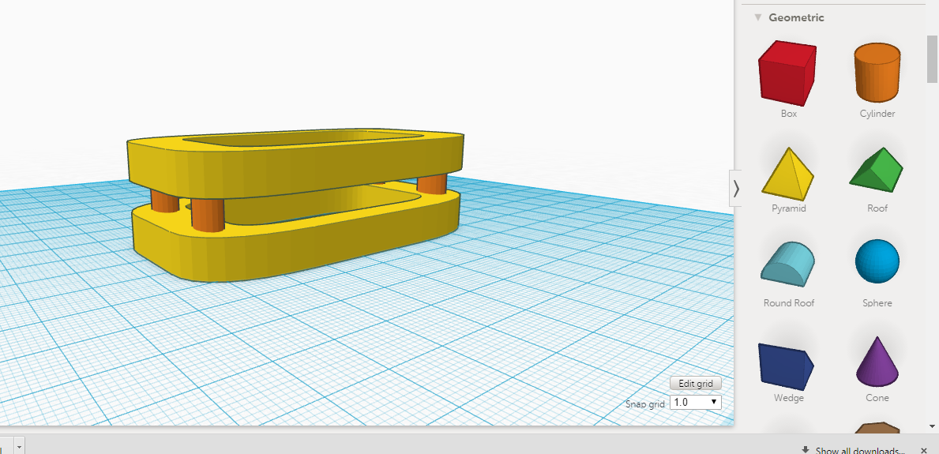

Brainstorm Questions

Directions: Answer the following questions to help guide your ideas of your house to design and sketch. Feel free to share with peers and mentors in order to generate more ideas! Continue to reference the essential questions for guidance.

1. What would your safe place look like?
2. Where could you go and hide away?
3. What would you use your house for?
4. What part of the project are you the most excited about?

**Important Factors**

*Dimensions of your house…*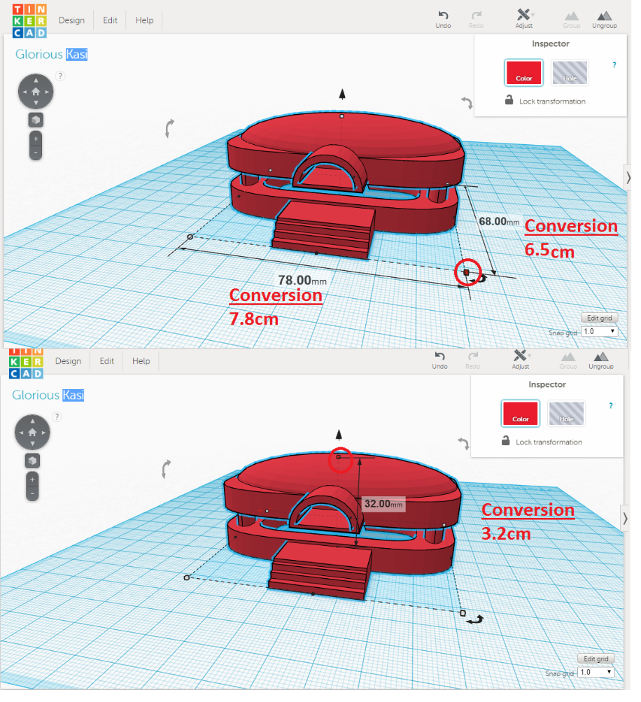

|  |
| --- |
| CM 🡪 MM |
| CM x 100 = MM |
| MM 🡪 CM |
| mm/100 = cm |

Tinkercad works in millimeters (1 mm = 0.1 cm)

Get Creative! Houses, castles, igloos, treehouses, and more! Use your imagination!

*Imagination is more important than knowledge. Knowledge is limited.*

*Imagination encircles the world.*

*-Albert Einstein*

Tinkercad Shape Inventory

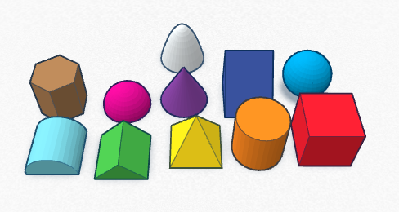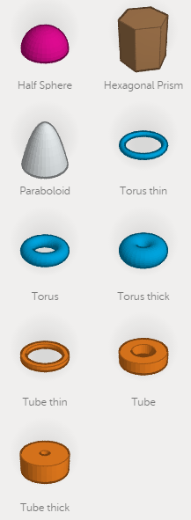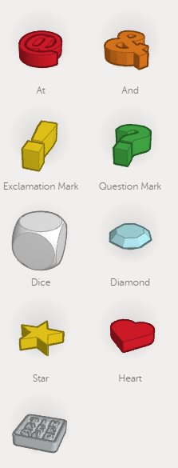

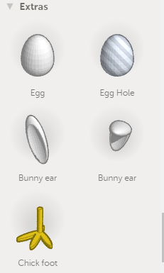

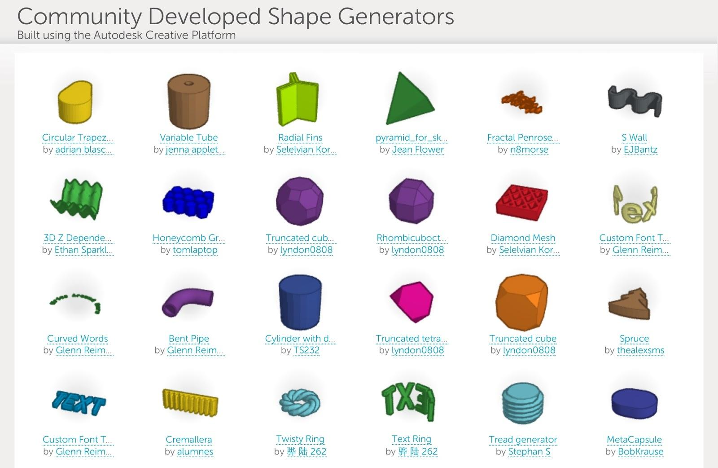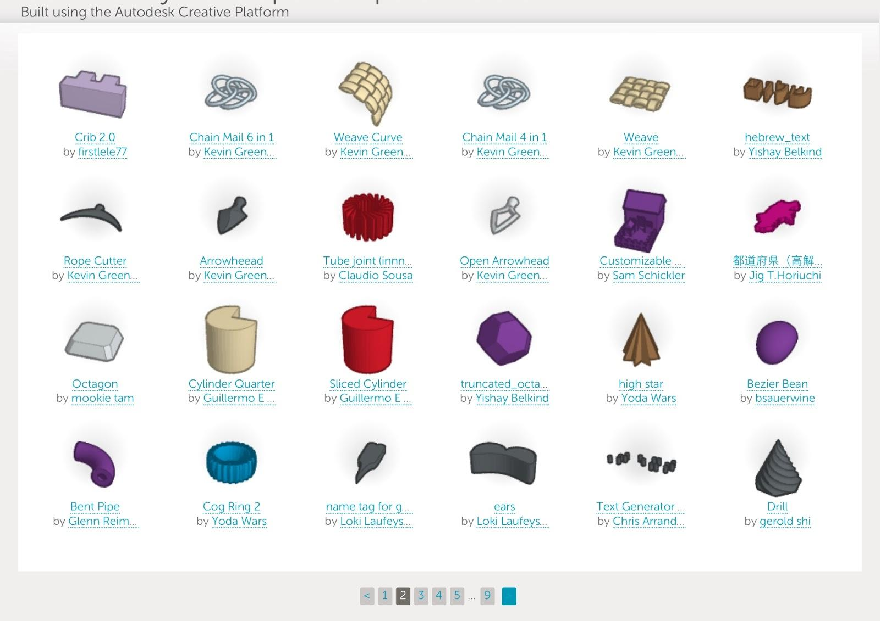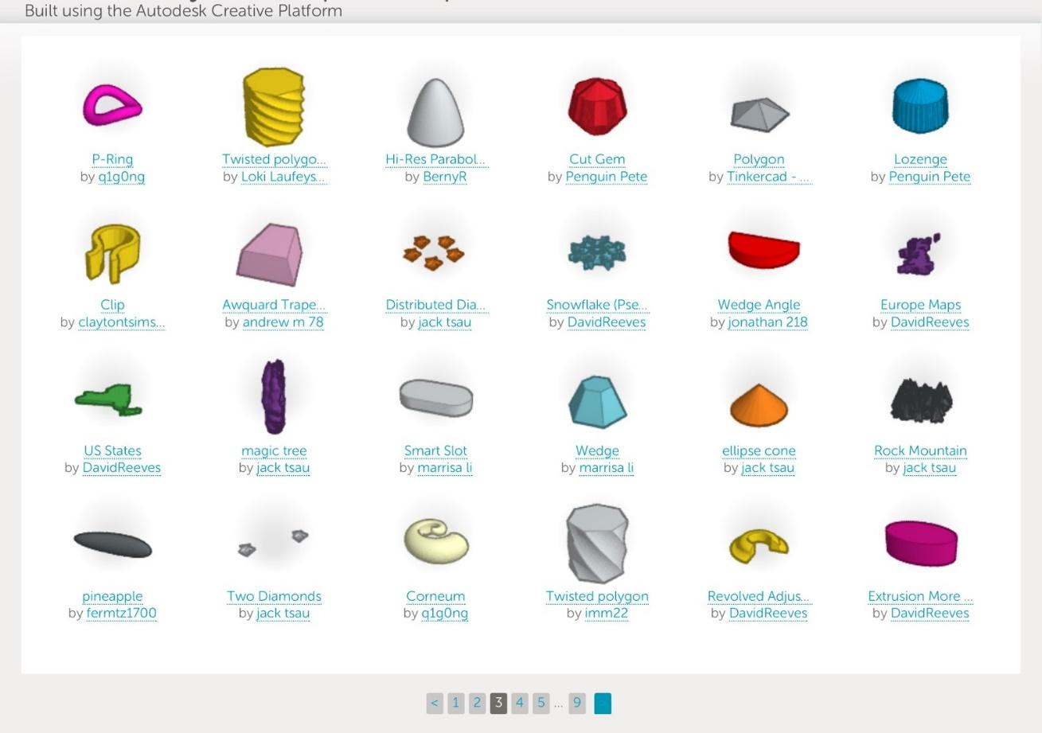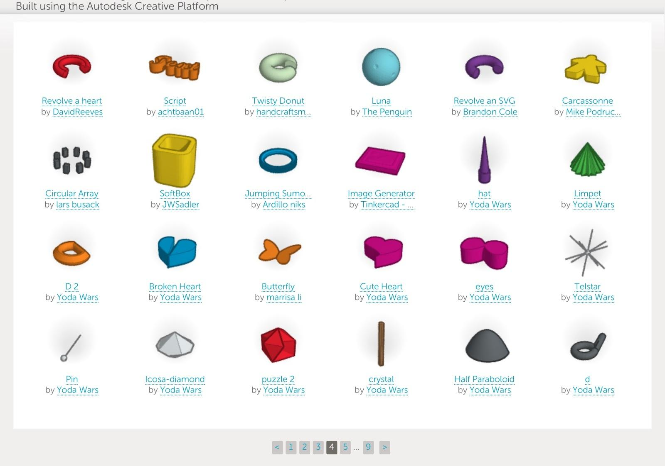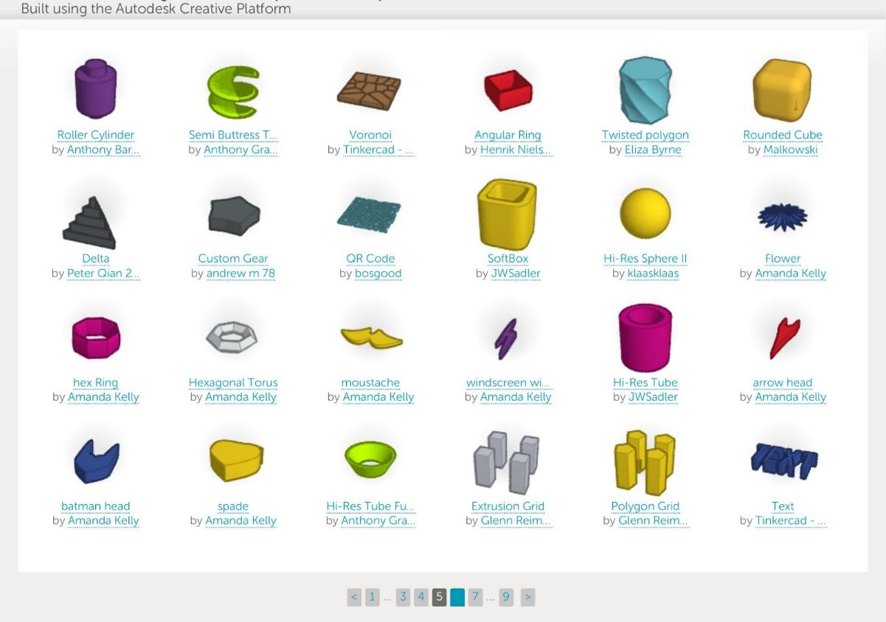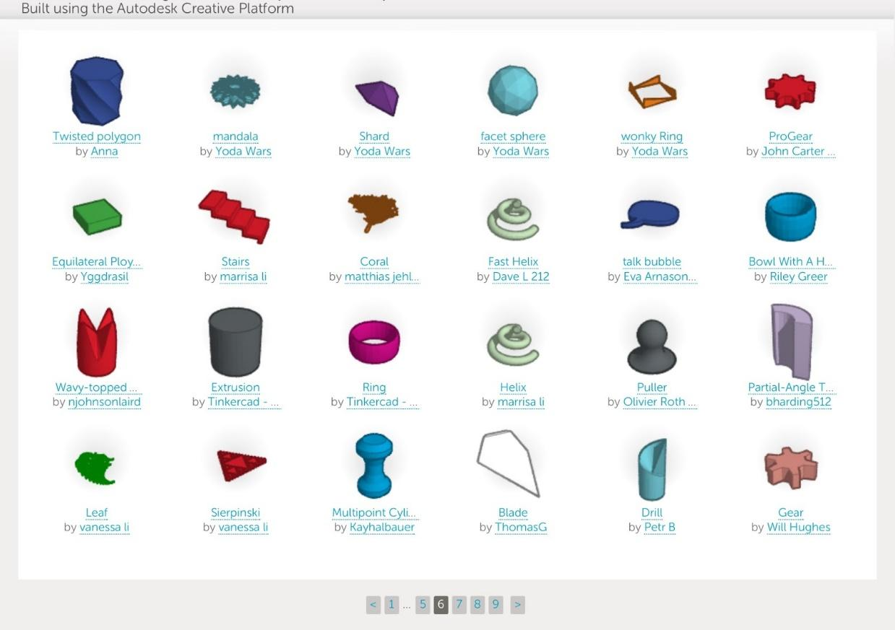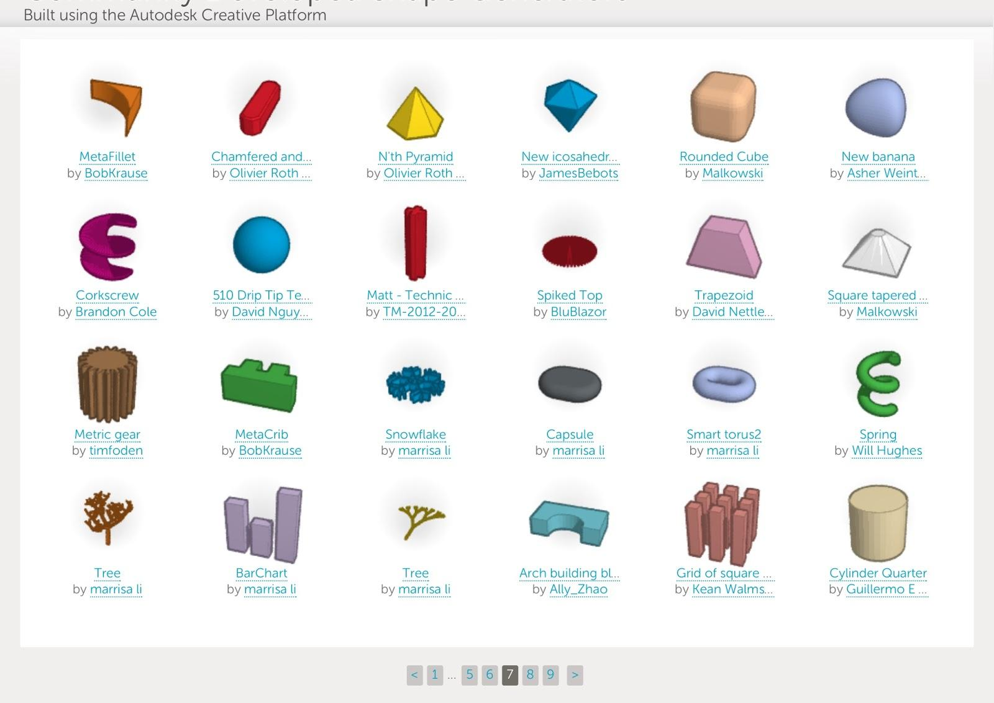

*All letter & number are included in the inventory on Tinkercad

|  |
| --- |
| Remember: |
| Time  Size  Support  Personal Creativity  Answers to questions |

House Sketch One

|  |
| --- |
| Remember: |
| Time  Size  Support  Personal Creativity  Answers to questions |

House Sketch Two

**Helpful Hints**

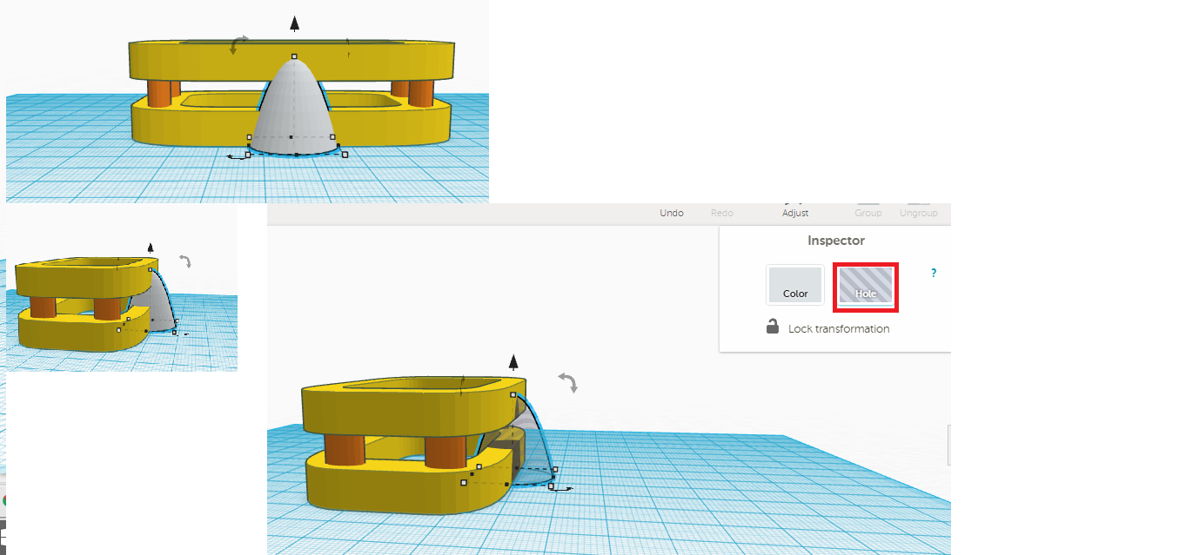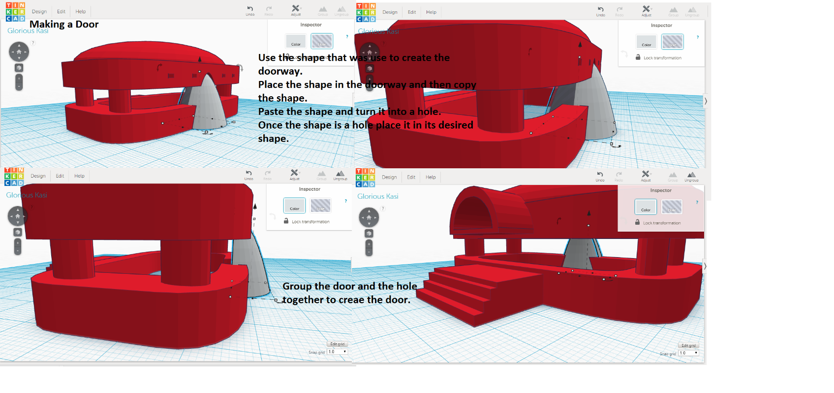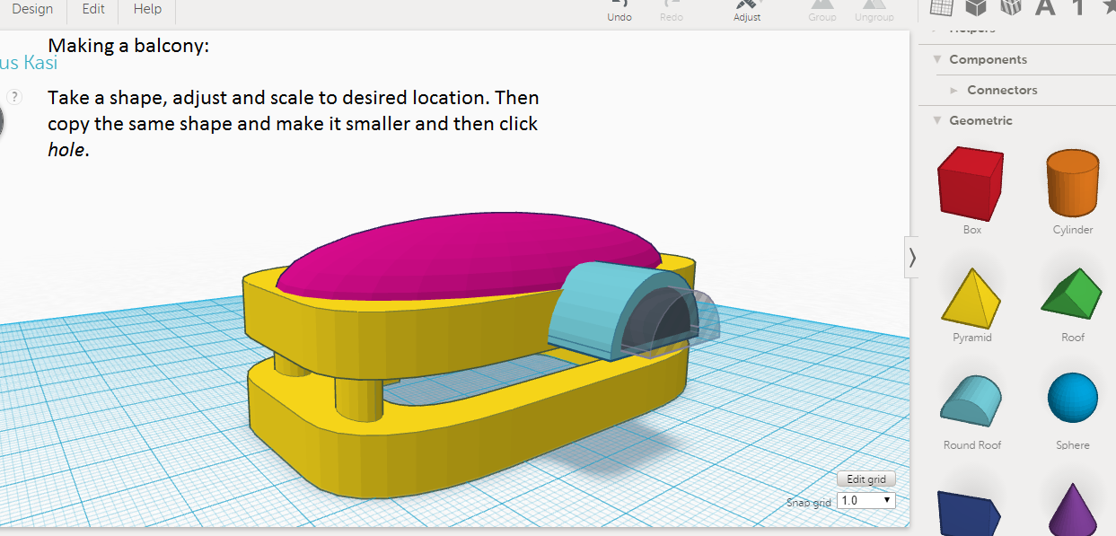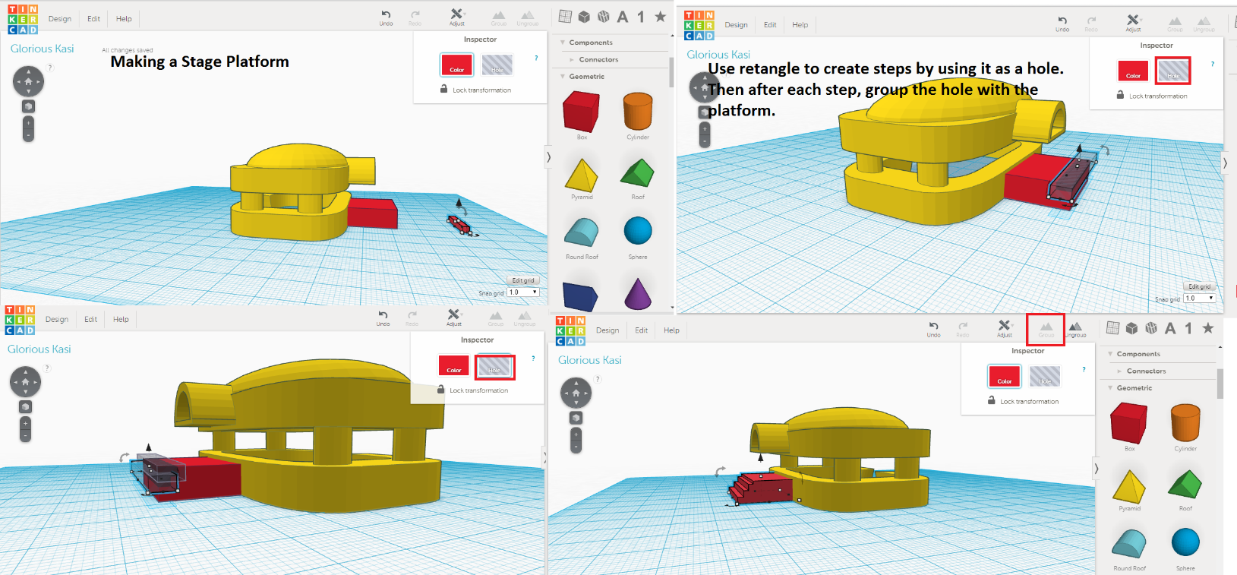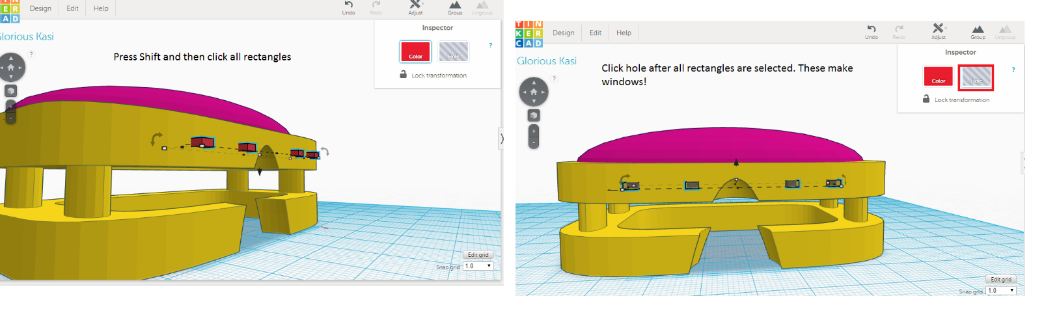

**Example of Finished House**

